Five Digits

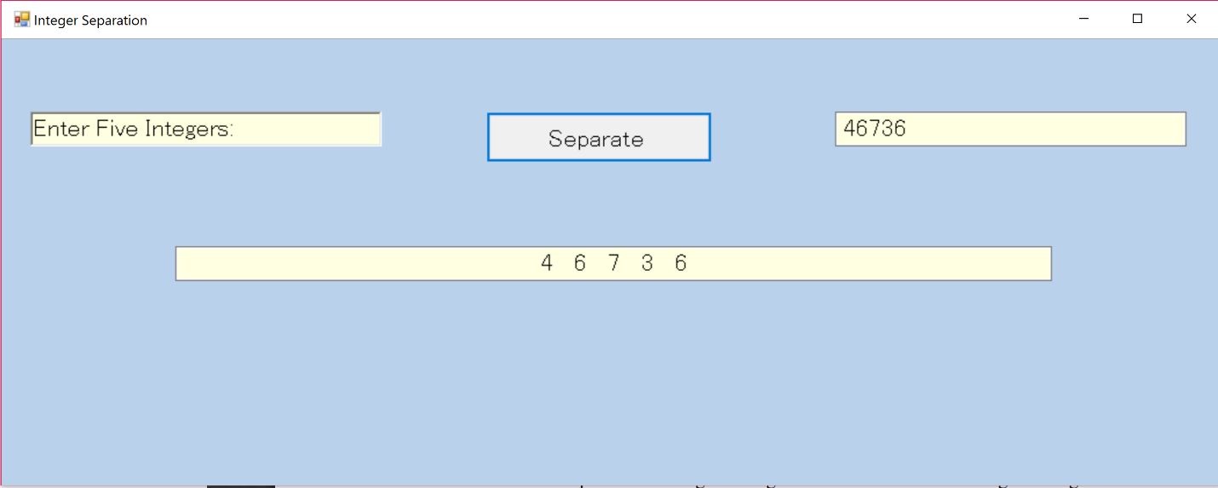

Questions

1) What happens when you execute the app and type a number with more

than 5 digits?

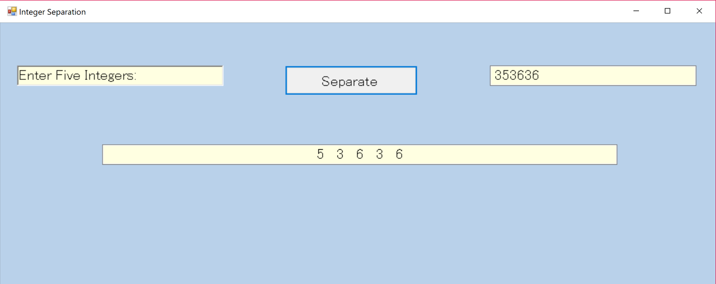

2) What happens when you execute the app with fewer than five digits?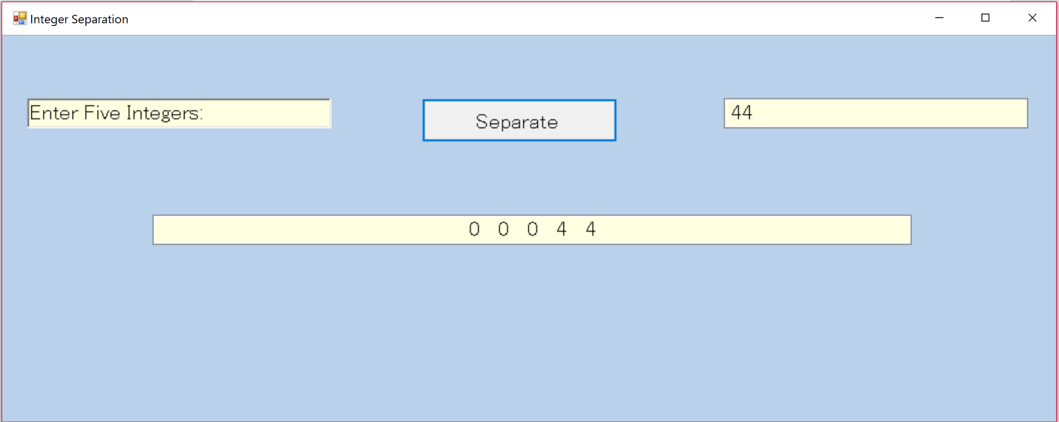

**Bonus**

Less than 5 digits

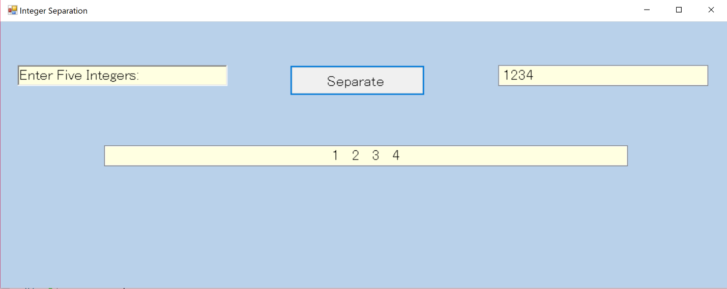

More than 5 digits